**PIZZA SALES REPORT**

**A.KPI’s**

**1. Total Revenue:**

select

sum(total_price)as total_revenue

from pizza_sales

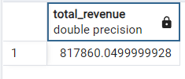

**2. Average Order Value:**

select

count(distinct order_id)as total_order,

round(sum(total_price)::numeric/count(distinct order_id)::numeric,2) as average_order_value

from pizza_sales

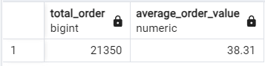

**3. Total Pizzas sold:**

select

sum(quantity)

from pizza_sales

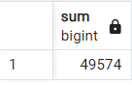

**4. Total Orders:**

select

count(distinct order_id)as total_orders

from pizza_sales

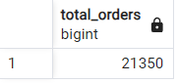

**5. Average Pizzas per Order:**

select

round(sum(quantity)::numeric/count(distinct order_id),2)as average_pizzas_per_order

from pizza_sales

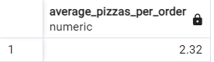

**B. Daily Trend for Total Orders:**

select

extract(dow from order_date)as daily_trend,

count(distinct order_id)as total_orders

from pizza_sales

group by 1

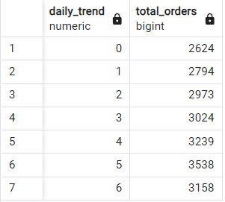

**C. Monthly Trend for Total Orders:**

select

extract(month from order_date)as monthly_trend,

count(distinct order_id)as total_orders

from pizza_sales

group by 1

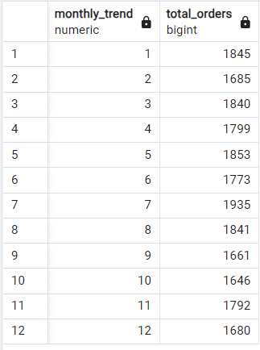

**D. % of Sales by Pizza Category:**

select

pizza_category,

round(sum(total_price)::numeric,2)as total_revenue,

round((sum(total_price)*100)::numeric/(select sum(total_price)from pizza_sales)::numeric,2) as PSC

from pizza_sales

group by 1

order by 3 desc

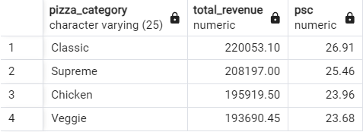

**E. % of Sales by Pizza size:**

select

pizza_size,

round(sum(total_price)::numeric,2)as total_revenue,

round((sum(total_price)*100)::numeric/(select sum(total_price)from pizza_sales)::numeric,2) as PSC

from pizza_sales

group by 1

order by 3 desc

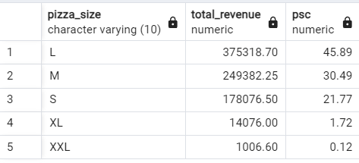

**F. Total Pizzas sold by Pizza Category:**

select

pizza_category,

sum(quantity)as total_pizza_sold

from pizza_sales

group by 1

order by 2 desc

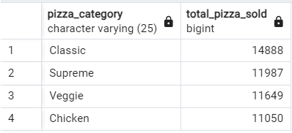

**G. Top 5 Pizzas by Revenue:**

select

pizza_name,

round(sum(total_price)::numeric,2) as total_revenue

from pizza_sales

group by 1

order by 2 desc

limit 5

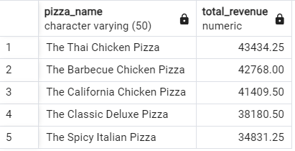

**H. Bottom 5 Pizzas by Revenue:**

select

pizza_name,

round(sum(total_price)::numeric,2) as total_revenue

from pizza_sales

group by 1

order by 2

limit 5

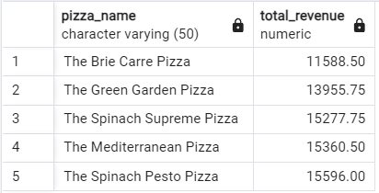

1. **Top 5 Pizzas by Quantity:**

select

pizza_name,

sum(quantity)as quantity

from pizza_sales

group by 1

order by 2 desc

limit 5

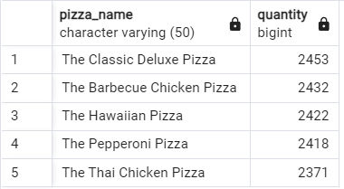

**J. Bottom 5 Pizzas by Quantity:**

select

pizza_name,

sum(quantity)as quantity

from pizza_sales

group by 1

order by 2

limit 5

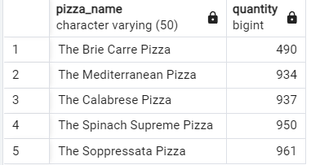

**K. Top 5 Pizzas by Total Orders:**

select

pizza_name,

count(distinct order_id)as total_orders

from pizza_sales

group by 1

order by 2 desc

limit 5

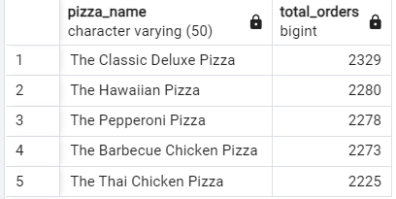

**L. Bottom 5 Pizzas by Total Orders:**

select

pizza_name,

count(distinct order_id)as total_orders

from pizza_sales

group by 1

order by 2

limit 5

